Date Stamping - Incoming Applications

Thursday, October 15, 2015

9:14 AM

**Hard Copy (Front Desk or Fax)**

Hard copy applications may come in via the mail, dropped off in person by a provider or via fax machine. These documents are manually date stamped with the date stamping machine in the PCC Copy room.

The staff who pre-processes documents up should check for additional staples, paper clips and other clips along with unique size paper so that date stamping will go smoothly.

All pages of the application at the time of receipt and subsequent documents sent after the application is pended must be date stamped whether they are received by fax, hand delivered, mailed, or emailed.

All documents that come in via fax or front desk by drop off or mail need to be date stamped with **SDS CERT <date rec’d>**.

**All Documents**

* + **Clear settings** – press the **Stop/Clear button** then **Yes**

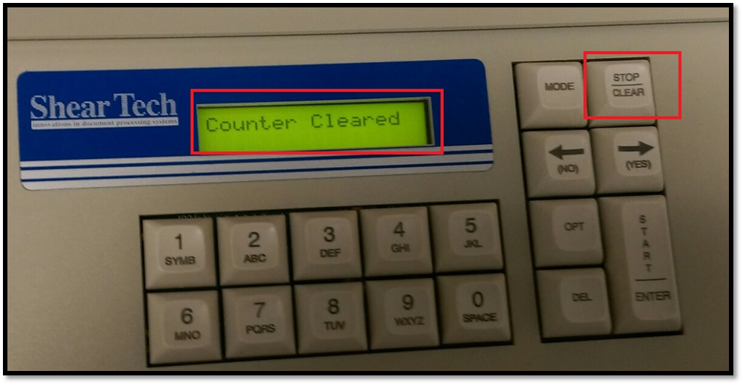

* + **Insert the documents** *face up* with *footer to the right side*

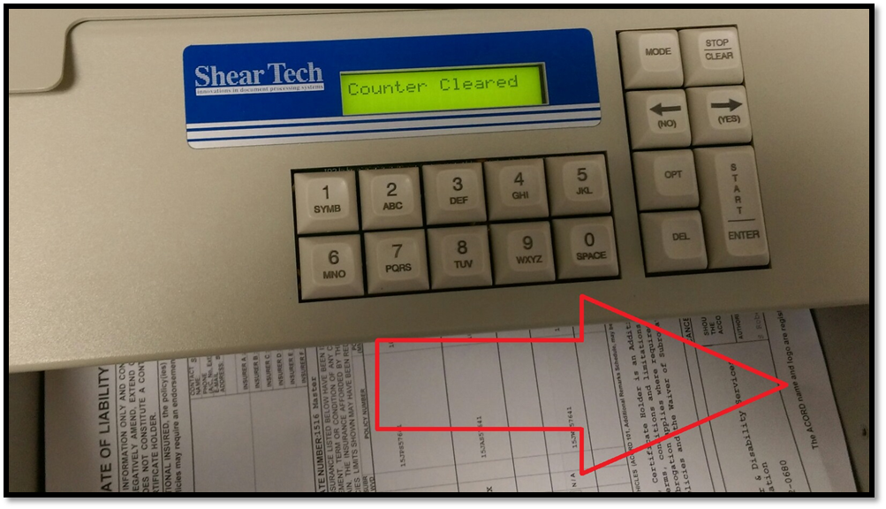

* + Push **Mode** then **Start**.

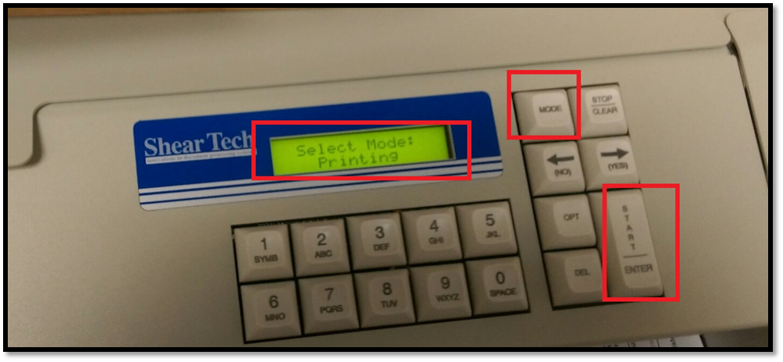

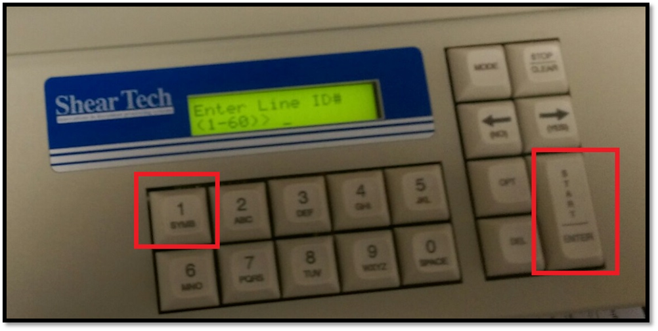

* + **Line ID** press **1** and **Start**
  + **Selected Line** just *ignore* and press **Start**

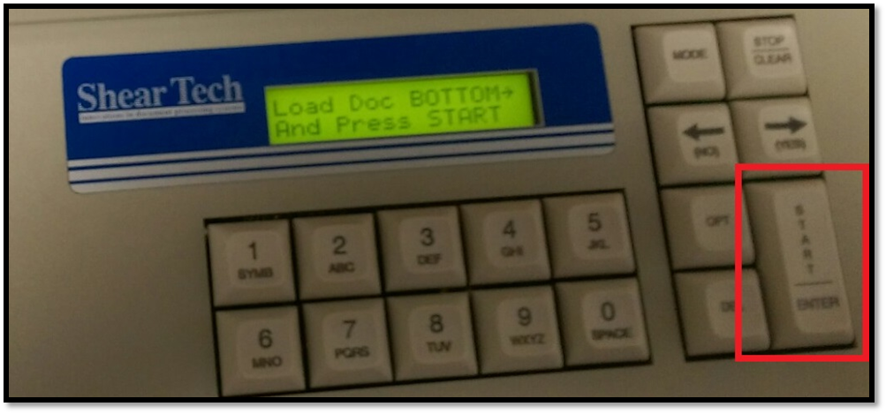

* + **Enter Alpha** using the keypad (multiple press on same key for different numbers and letters) always enter “***SDS CERT***” as the start, then the date the item was rec’d i.e. **SDS CERT OCT 26 2015**

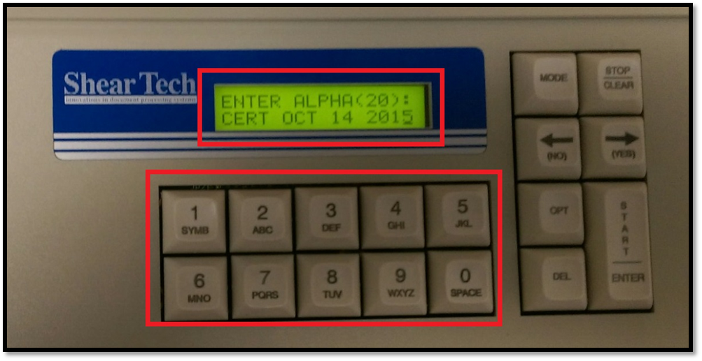

**Note:** that FEB will also require using the Yes/No Arrow keys to move from the “F” to the “E” the same action is applied to “11” and “22”

* + Push **Start**
  + *Ignore* **Enter Digits** an*d push* ***Start***

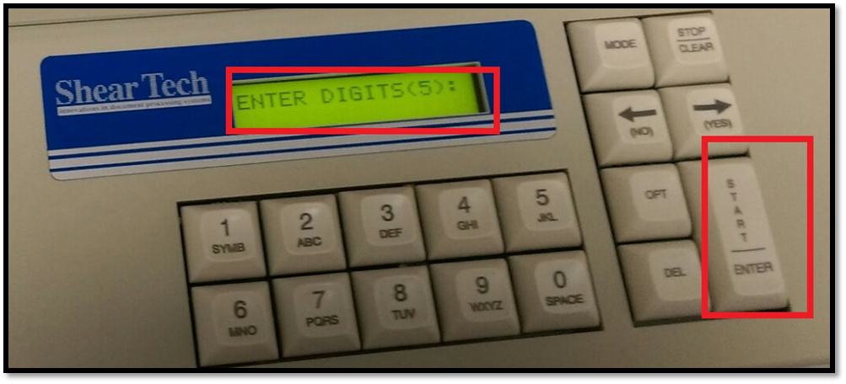

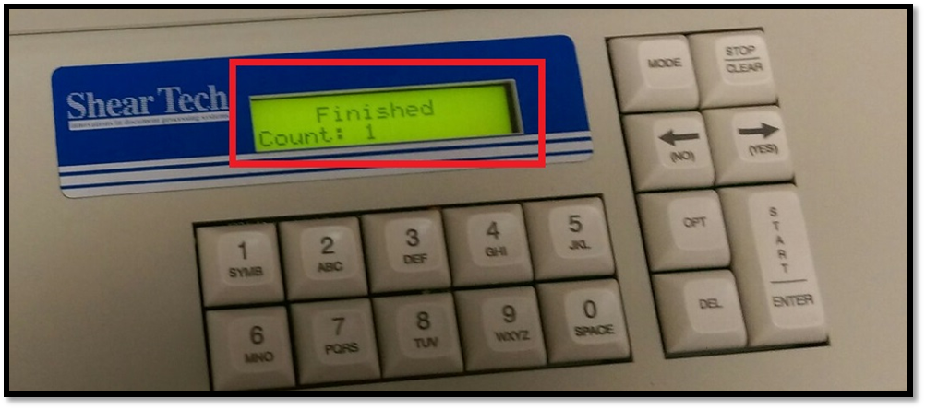

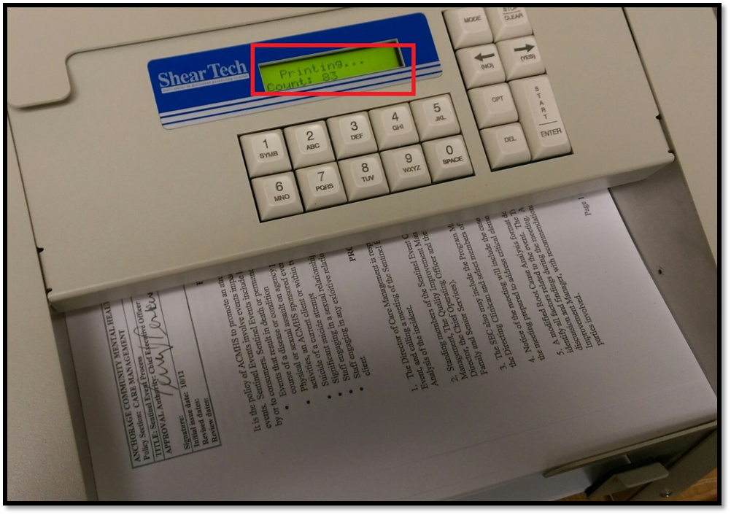

If multiple packets of documents are on the same date you can simply clear the counter and push start again for the same date but a restart of the Bates Numbering function.

**Transport errors** needs PHOTOS

Transport errors happen when staples are missed in preprocessing of the documents. Some paper types also cause Transport Errors for unknown reasons.

* + **Open** the top hatch
  + **Undo** the *finger screws*
  + **Gently pull** the paper out from the top
  + **Use the rollers** to assist in moving the paper forward or backward until an edge can be grasped
  + OR from the bottom reach in and gently but firmly and evenly pull the paper out
  + Push the **Stop/Clear** button to continue
  + Determine if it needs to be sent through a second time and either push **Yes** or **No**